# Assignment 3: Business and functional model

Date: 23/08/2022. Group: 5

| **Team member name** | **Student ID number** |
| --- | --- |
| **Justine Castellani** | 40114450 |
| **Carolina Hassid** | 40058449 |
| **Alain Euksuzian** | 40070126 |
| **Loric Vezin** | 40113694 |
| **Thuc Anh Kim** | 40129214 |
| **Farhan Samin Prionta** | 40107504 |

**Description of the assignment:** Using Visible Analyst, Visio or another software that has the same functionality, you are required to create functional models of the main business processes for your project using use-case diagrams, activity diagrams, and use-case descriptions. A minimum of three (3) business processes are required and for each of these a minimum of one (1) use-case diagram, one (1) activity diagrams, and one (1) use-case descriptions.

As before, this project will be used for all the assignments in this course during the semester, as we will be evolving this idea towards a more complete system analysis and design.

The assignment must be done in teams of 3 or 4 students. The same teams as assignment 1 and 2, unless an arrangement has been made to change the teams.

The assignment is worth 5% of the final grade for this course.

Late assignments will be penalized by 20% per week.

***We decided to set the deadline for the 23rd of October.***

Farhan: Use case 8

Alain: Use case 1

Kim: Use case 10

Loric: Use case 6

Justine: Use case 4

Caro: Use case 2

**Business process 1: Order Confirmation**

**Summary**:

As a customer, I want to confirm my order so that I can ensure that the products have been reserved for me. I also desire to receive the order ID to keep up with my order.

As the Website manager I want to make sure that the payment information and delivery addresses were correct so that the clients may receive my product.

**Owner:** Capcium Website Manager

**Actor**: All customers

**Preconditions**: For this use case to kick in, the user must have already catered their shopping cart and have registered all their personal information for the order.

**Postconditions:** At the end of the use case, the Actor should have acquired an order number (allowing him to keep track of their order). All information required for the order must also be accurate.

**Description**: This use case describes how a customer can confirm their order on the system and retrieve the necessary information for the order follow-up.

**Normal flow of events:**

1. The customer finishes his overview of his shopping cart on the “shopping cart” page.
2. The customer now clicks on the “confirm” button at the bottom of the screen.
3. The site now reviews that the products are available.
4. The site then checks that the delivery information is a real place and can be serviced.
5. The site then checks that the payment information (billing info, etc.) corresponds to the right bank account and customer.
6. The site now generates an order number and saves all this information in a virtual dossier.
7. The site now displays a resume of the information with the order number on a new page “your orders”
8. The customer can examine the information he desires, and the business process ends there.

**Exceptions**: If the user does not have the sufficient funds to pay for the products, the order ID will still be generated but it will be cancelled later, as Capcium receives a message warning them that the payment has not gone through (this can only be checked after the fact).

**Priority:** High

**Category:** Functional / Required process

**USE CASE DIAGRAM**

**Activity Diagram:**

**Business process 2: Checking availability of items (**Justine)

**Summary**:

As a customer, I want to check to make sure the products I am adding to my shopping cart are still available before checking out and placing my order.

As the Website manager I want to make sure that the quantity of each product available on the website is correct.

**Owner:** Capcium website manager

**Actors**: Customer

**Preconditions**: Users must be on the company’s website. Then, they must choose the items they want to add to their shopping cart. However, for them to add only available products to their shopping cart, the website owner must make sure stock availability is updated in real time through an automated process.

**Postconditions:** If no stock is available, put a label on that product stating ‘This item is out of stock’

**Description**: This use case describes if customers can add an item in their shopping cart based on its availability

**Normal Flow of events:**

1. Customers browse the website’s catalogue in order to find the items they are looking for.
2. The customers select the items that they want to buy and will click on “add to shopping cart”.
3. Before step 2 is validated by the system, the site will review that the products are available.
4. If the items are available, they will be added to the shopping cart.
5. If the items are not available, the website will notify the customers. On the site, they will be able to see the message “out of stock” for those items.
6. The site will suggest other products with a similar use, and which are available for the items “out of stock”

**Exceptions**: No exception

**Priority:** **High**

**Category:** functional / required process

**USE CASE DIAGRAM**

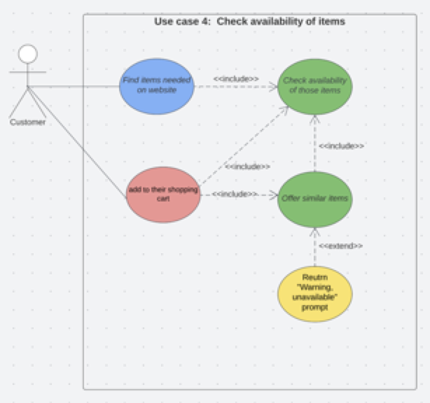

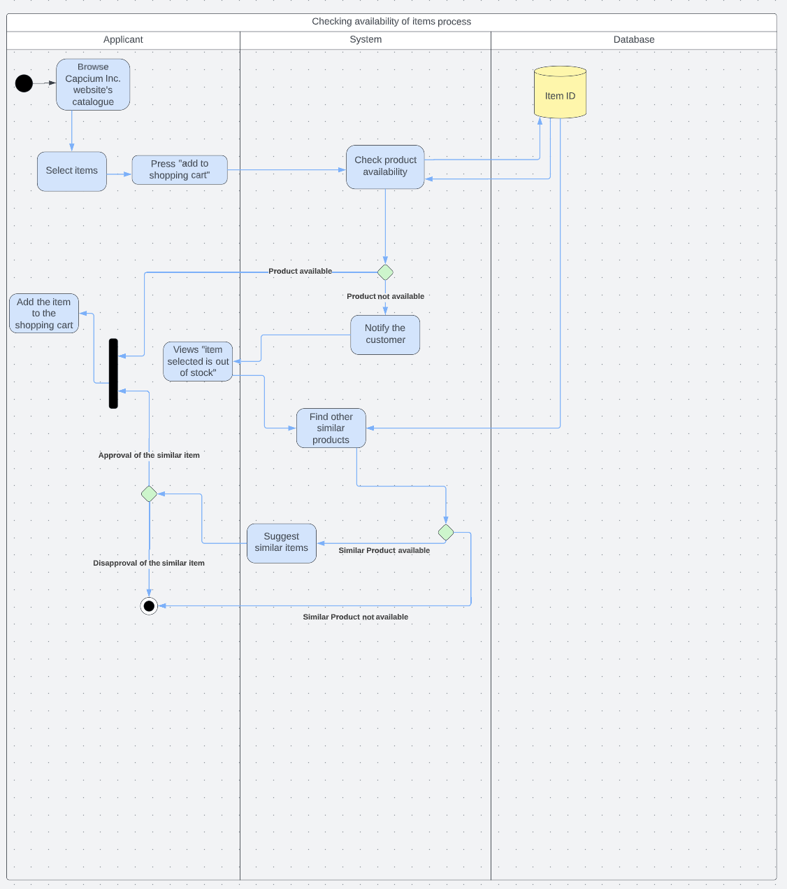

**Business Process 3 - adding items to shopping cart (Caro)**

**Summary**:

As a customer, I want to add one or several products to my shopping cart so that I can place my order and pay.   
  
As a Capcium website manager, I want the user to checkout and pay within X minutes of adding an item to their shopping cart.

**Owner:** Capcium website manager

**Actor**: Customer

**Preconditions**: Customers must go to the company’s website and log in or sign up if not done yet. They will then either browse the website catalogue and find their desired products ~~or directly select the product.~~

**Postconditions:** After adding all the products the customers need, they will have to place their order and pay within a specific amount of time.

**Description**: Once the customers are on the company’s website, they will have the opportunity to search for various products. They will have the option to send items to the shopping cart by selecting the quantity of that product (ex: 1, 2, 3, etc.) and its specific package type (ex. 200g, 500g, 1kg, etc.). The shopping cart will be updated each time a product is added. Once the user is done adding items to their cart, the system will give the user 10 minutes of inactivity before displaying a timer, indicating that they need to proceed to the checkout and pay within X minutes  
  
  
**Normal Flow of events: (to change)**

1. Customers browse the website’s catalogue in order to find the items they are looking for.
2. Customers will select the items that they want to buy, select the quantity of the item, select the item type and will click on “add to shopping cart”.
3. The shopping cart will be updated when a new item and their respective quantities and types are selected.
4. Customers will have a period of up to 10 minutes to checkout and pay before the system intervenes.
5. If the 10 minutes of inactivity pass, the system will display a message and timer indicating that the customer has X minutes to checkout and pay.
6. If X minutes pass and a payment has not been made, the stock in this customer’s shopping cart is taken off hold for this customer and displays as available for other users.
7. Customer’s shopping cart will display as empty and will need to re-add the items they desire to purchase to it.

**Exceptions**: If the customers want to add a product, but this specific item is out of stock, it will let the customers know

**Priority:** **High**

**Category:** functional / required process

**USE CASE DIAGRAM 2**

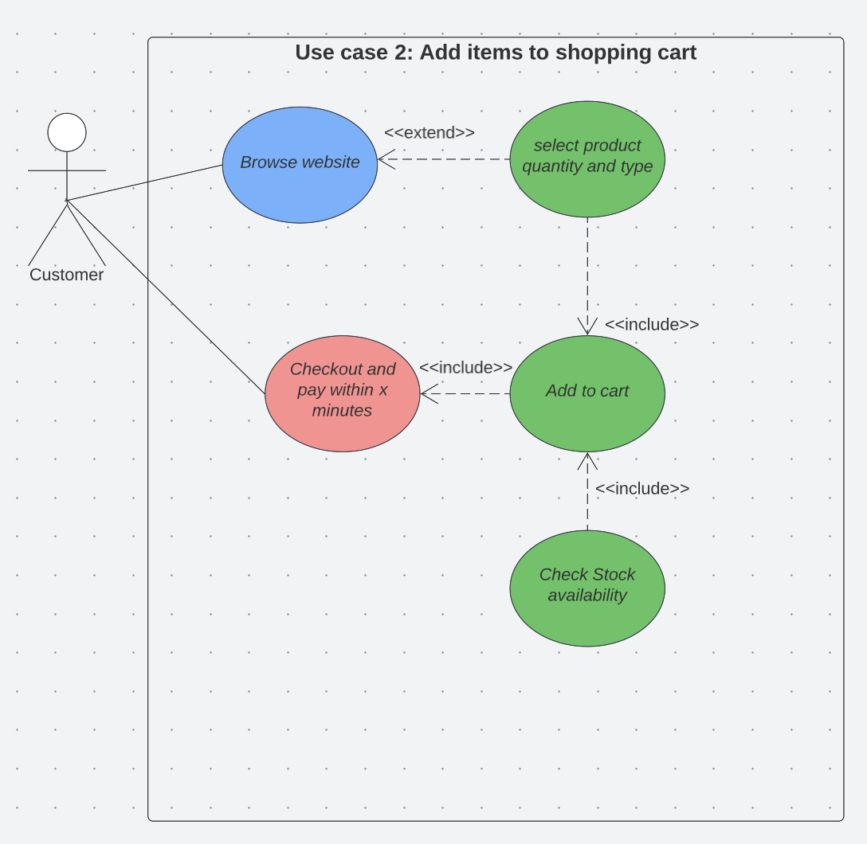

**Business Process 8 – Receiving files and processing information**

**Summary:**

As the website manager, I want to see how efficiently the overall process of file uploading and information processing works. The flow and proper rhythm of information helps me understand if the information flow is going to the appropriate database and required stakeholders.

**Owner:** Website Manager

**Actor(s):** Customer

**Preconditions:** Customer must upload the file containing the recipe for formulation/encapsulation or ingredient list.

**Postconditions:** The information is then accessible by authorized departments and individuals, who can use it for their tasks as required.

**Description:** Customer Logs in as required and fills up the product questionnaire. They are also prompted to upload the file containing encapsulation/formulation recipes or ingredients list. The uploaded file is then stored in the production database. The system then extracts product information from the questionnaire and uploads files. This extracted data is then used to populate an internal production database from where an internal document containing all necessary information is made visible to authorized stakeholders.

**Normal flow of events:** (Waiting for previous parts to be done)

**Exceptions:** Customers unwilling to sign up due to privacy or personal reasons won’t be able to fill out the questionnaire or upload files resulting in no progression or order.

**Priority:** High

**Category:** Functional/Required Process

**USE CASE DIAGRAM 8**

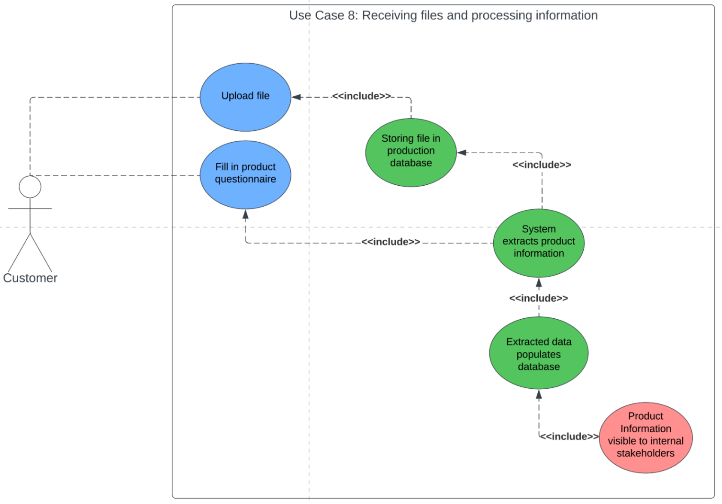

**ACTIVITY DIAGRAM 8**

